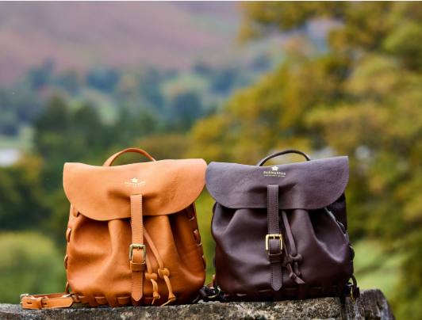 | CWFWI Harvest Supper  including Trophy Presentations  Monday 28th September  Endmoor Village Hall,  LA8 0HQ  Please note the new venue  7pm, £20 per person  Speaker: Claire Beaumont of Parnassus Leather | 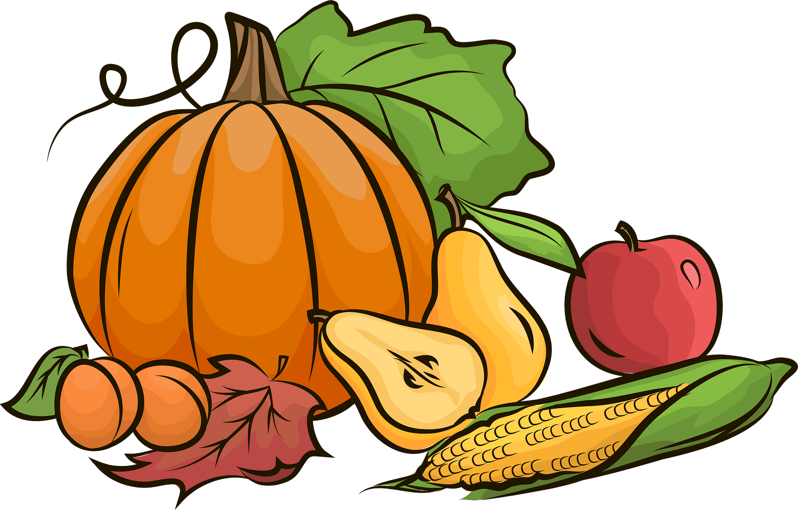  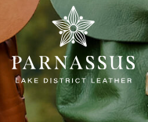

Join us for what promises to be a fascinating and inspiring event as we welcome Claire Beaumont of Parnassus Leather as our guest speaker. Claire and her husband Sam run a regenerative farm in the Lake District and, driven by a desire for reducing waste, creating a circular economy, and producing timeless fashion, founded Parnassus Leather – a fully traceable, sustainable luxury leather brand. Their story demonstrates how traditional farming, environmental responsibility and high-quality craftsmanship can work hand in hand.
As well as hearing about this innovative venture, you will enjoy the presentation of this year's Show Trophies, making it a wonderful opportunity to celebrate the achievements of our members.
at an informative and enjoyable occasion with delicious food included.
You can book using this form or online at cwfwi.org or by contacting the office directly.
Please book by Friday 11th September.

Please don’t forget to include an emergency contact number and let us know about any dietary requirements or special needs.

Name of WI: ……………………………………………………………

Name | Email | Emergency Contact No | Payment £20

Please tell us below if anyone named above has any dietary requirements or special needs that we should be aware of.

…………………………………………………………………………………………………………………

………………………………………………………………………………………………………………….

TOTAL PAYMENT ………….

Places are limited so please book early to avoid disappointment.

Please send in your applications on this form no later than 11th September
or
you can apply by the cwfwi.org website or pay by BACS: Account no: 67226995,
sort code 08-92-99 code Harvest 26, cheques to CWFWI
Please return this form by email or post to:
WI Office, Kendal House, Murley Moss, Kendal, LA9 7RL

